Day of Mourning Toolkit for Unitarian Universalist Congregations
Created by EqUUal Access

Over the past 12 months, 70 people with disabilities have been killed by their parents or caregivers, according to the Autistic Self Advocacy Network (ASAN). Perhaps, even more appalling, though, is the way in which the media portrays these murders. Often, these crimes are excused. The murderers are treated with sympathy, their victims are referred to as 'burdens,' and the public is led to believe that these sorts of crimes are 'justifiable' and 'inevitable.'
Well, as the parent of a child with a disability, I am here to tell you that my child is not a burden. Her disability is not a burden. And, she deserves full protection under the law. This is why I have helped EqUUal Access, the Unitarian Universalist Association's foremost disability rights organization, create this resource for the Day of Mourning, March 1st, 2016.
The Day of Mourning is an opportunity to pause and remember those lost, bring awareness to these tragedies, and demand justice and equal protection under the law for all people with disabilities. Our hope at EqUUal Access is that UU congregations across the United States will organize to hold or attend local vigils on this day. However, we also understand that is not always possible. Sometimes, our congregations are limited in what they can do. Whatever the case may be, though, EqUUal Access is here to help. We have created this toolkit for your congregation. It includes a FAQ sheet, sample press releases, social media resources, as well as articles and action steps everyone can utilize.
Our Unitarian Universalist principles proudly proclaim the “inherent worth and dignity of every person,” and they call on all of us to build a “world community with peace, justice, and liberty for all.” Today, I am calling on all UU congregations to proudly proclaim that people with disabilities have ‘inherent worth and dignity.’ Today, I am asking you to fight for ‘peace, justice, and liberty.’ Today, I invite you to join us on the Day of Mourning.

Meredith Plummer
Director of Family Programming,
First Unitarian Church of Cincinnati
EqUUal Access Policy Chair

Frequently Asked Questions

What is the Day of Mourning?
“For the last [five] years, the Autistic Self Advocacy Network, ADAPT, Not Dead Yet, the National Council on Independent Living, the Disability Rights Education & Defense Fund, and other disability rights organizations have co-sponsored or held vigils across the nation to mourn those whom we’ve lost, to raise awareness about these tragedies, and to demand justice and equal protection under the law for people with disabilities. “ – The National Council on Disability
When is it?
For the past few years, the Day of Mourning has been held on March 1st.
Does my congregation have to organize a vigil?
It is our hope that your congregation would organize to hold or attend a local vigil. However, we understand that this isn’t always possible. That is why, in this toolkit, you will find a few resources to help you and your congregation honor the Day of Morning over social media, and at home.
How do I know if there is a vigil being organized in my area?
Every year, ASAN compiles a list of Vigil Sites and organizers. If there is a vigil already planned in your area, you can find out there.
My congregation would like to hold a vigil, but doesn’t know where to begin. What should we do?
First, make sure there are no other vigils planned in your area. If there are, then I suggest you offer to help instead of organizing your own vigil.
However, if there aren’t any vigils planned in your area, then you can use ASAN’s Anti-Filicide Toolkit to help you plan your own vigil.
Finally, be sure to use the news release format in this toolkit to help you publicize your vigil. Add personal details that would get the attention of your local media – ask yourself why it would be important for your larger community to know about the event. Send it to local media who have covered stories of people with disabilities, or journalists who usually cover humanitarian-angled stories.
What can my congregation do to help people with disabilities on a regular basis & for outreach ministries?
Visit EqUUal Access’s website.
Consider becoming AIM-certified. The “Accessibility and Inclusion Ministry (AIM) focuses on welcoming, embracing, integrating, and supporting people with disabilities and their families in our congregations. Its sacred challenge for congregations is recognizing the humanity and gifts of all people.” – Unitarian Universalist Association

MEDIA KIT
Reach out to the Press
On the following 2 pages you will find a customizable template for a press release for a local vigil.
If your congregation is organizing a vigil in your community, you’ll find additional information about contacting the local media and links to a customizable template in ASAN’s How To Hold a Vigil: Site Coordinator’s Handbook
If you will be joining a vigil that others are organizing, try to coordinate your media outreach to augment theirs.

FOR IMMEDIATE RELEASE
[Date]

CONTACT: [Your name goes here]
[Your title goes here]
[Your phone number here]
[Your email address here]
LOCAL CONGREGATION TO JOIN VIGIL FOR MURDERED PEOPLE WITH DISABILITIES NATIONWIDE
Community Commemorates Lives of Disabled Filicide Victims

[Your City, Your State].—As part of a nation-wide Day of Mourning, members of [your congregation] will join with disability rights advocates in [your city] in holding a vigil on March 1, 2016 to honor the lives of disabled people murdered by their families and caretakers.
Over 180 such murders have been reported in the United States in the last five years, over 70 in the last year alone. The total number of killings is likely higher than the amount which are reported in the news media. We must address violence against people with disabilities and speak out against the dangerous cultural prejudice that says a disabled life is not worth living.
The Autistic Self-Advocacy Network, Not Dead Yet, and the National Council on Independent Living held the first Day of Mourning in 2012 as a response to the murder of George Hodgins, a 22-year-old autistic man from California, by his mother. Day of Mourning is a national event, with around fifteen participating cities each year.
Little or no public attention is paid to the disabled victims of these horrendous acts. Media coverage and public discourse about such killings frequently justifies them as “understandable” and sometimes “merciful,” rather than appropriately condemning these crimes and those who commit them. The national Day of Mourning is a time for the disability community to commemorate the many lives cut short. By honoring disabled victims of murder and celebrating the lives that they lived, these vigils send a message that disability is not a justification for violence.
The [your city] vigil will be held at [location], and begins at [time]. Speakers will include (name them, and their position if relevant as faith leaders, disability justice advocates or service providers.)

-MORE-
VIGIL/Page 2
About [Your congregation’s name] [Your congregation’s name] is located at [your congregation’s address]. Phone: [your congregation’s phone number]. Our mission is: [your congregation’s brief mission statement]. For more information, visit [link to your congregation’s website].
About EqUUal Access is a national grassroots organization of Unitarian Universalists living with disabilities, our families, friends, and allies coming together for a common purpose: To enable the full engagement of people with disabilities in Unitarian Universalist communities and the broader society. For more information, visit EqUUalAccess.org
About Autistic Self-Advocacy Network (ASAN) is an inclusive international non-profit organization run by and for autistic people. ASAN seeks to advance the vision of the disability rights movement in the world of autism. Drawing on the principles of the cross-disability community on issues such as inclusive education and community living, ASAN focuses on organizing the community of autistic adults and youth to have our voices heard in the national conversation about us. In addition, ASAN works to advance the idea of neurological diversity by furthering the view that the goal of autism advocacy should not be to create a world without autistic people. Instead, it should be to create a world in which autistic people enjoy the sme access, rights, and opportunities as all other citizens.
About Not Dead Yet is a national, grassroots disability rights group that opposes legalization of assisted suicide and euthanasia as deadly forms of discrimination against old, ill and disabled people. Not Dead Yet helps organize and articulate opposition to these practices based on secular social justice arguments. Not Dead Yet demands the equal protection of the law for the targets of so-called “mercy killing” whose lives are seen as worthless.
About The National Council on Independent Living is the longest-running national cross-disability, grassroots organization run by and for people with disabilities. Founded in 1982, NCIL represents thousands of organizations and individuals including: Centers for Independent Living (CILs), Statewide Independent Living Councils (SILCs), individuals with disabilities, and other organizations that advocate for the human and civil rights of people with disabilities throughout the United States.
###

Social Media Resources
Whether or not your congregation is hosting a vigil, attending a vigil, or neither, you can use these social media resources to educate your social media followers about the Day of Mourning, and why this issue should be a concern to Unitarian Universalists.
Pictures
Profile Pictures | 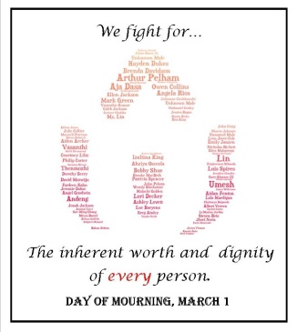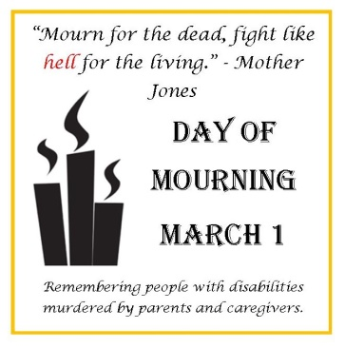
Cover Photo | 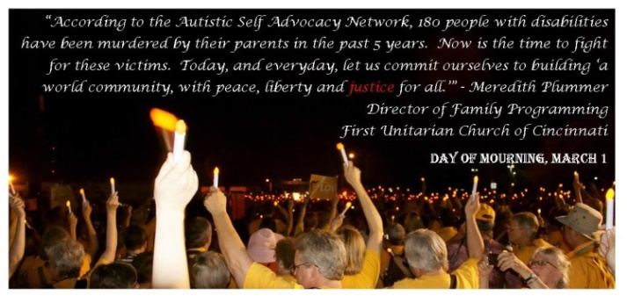
Other Photos | 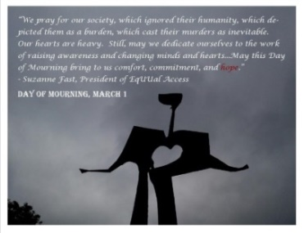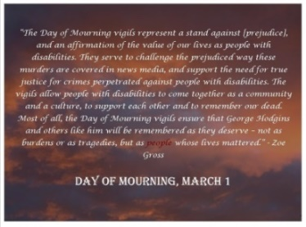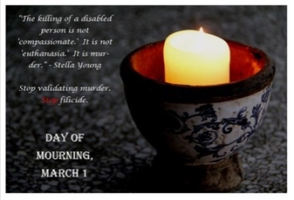

You can access and download all these images through google drive.
Action Steps You Can Take
For individuals who want to get involved, here is a short list of actions.
- Attend a Day of Mourning vigil wearing your yellow ‘Standing on the Side of Love’ shirt. Or, if you can’t attend a local vigil, attend a virtual one. Check ASAN’s website for more details.

- Call on local and state legislators to make disability part of your state’s hate crime laws if they aren’t already. Find your state legislator by checking out Open States website.

- Speak out whenever you see a prejudice reporting. Demand news organizations stop portraying these murders as justifiable.
Example: When Atlanta’s Alive 11 reported one such murder as a ‘Mercy Killing,’ disability activists spoke out and got the station to change their wording.
- Report. Yes, even yourself. If you think you might kill your child, call 911 immediately. If someone you know is talking about killing their child, call 911 immediately. If you suspect abuse or neglect, call 911 immediately. Often, after these tragedies occur, people close to the perpetrator report that the perpetrator made allusions to their intentions.

- Become informed. The videos and articles and videos listed in this toolkit are a good place to start. But the disability rights movement needs allies in the fight for jobs, fair pay, housing, and a great many other areas as well.

Videos and Articles
ASAN Article - Disability Community Day of Mourning
A good primer for anyone new to the Disability Day of Mourning, from the Autistic Self Advocacy Network.
TED Talk - Andrew Solomon: Love, no matter what
What is it like to raise a child who's different from you in some fundamental way (like a prodigy, or a differently abled kid, or a criminal)? In this quietly moving talk, writer Andrew Solomon shares what he learned from talking to dozens of parents — asking them: What's the line between unconditional love and unconditional acceptance?
Video - Stella Young: 'The assumption that my life has involved suffering is a prejudiced assumption'
Disability activist Stella Young says she didn’t consider her condition, Osteogenesis imperfecta, to “be a bad thing,” and says it has enriched her life.
Whitehouse Blog –Day of Mourning: Affirming the Value of Disabled People’s Lives
Zoe Gross, in being honored as a Champion of Change, speaks out on what the Disability Day of Mourning means to her as an American with a disability.
New York Times - Four Bodies in Elmhurst
Why would an 82-year-old man kill his son, his daughter, his wife and himself?
Thinking Person’s Guide to Autism – When Parents Murder Disabled Children: What You Need to Know
What you need to know: from autistic people, professionals, and parents.

Mission: To enable the full engagement of people with disabilities in Unitarian Universalist communities and the broader society.
- Raising awareness, empowering change, and promoting a framework for advocacy grounded in our Unitarian Universalist faith;
- Providing resources to help Unitarian Universalist communities become barrier-free and inclusive;
- Incorporating the gifts of ministry offered by people with disabilities into the faith community;
- Enabling Unitarian Universalist congregations to understand and minister to the spiritual and personal needs of people with disabilities, their families, and friends;
- Collaborating with other Unitarian Universalist organizations and the Unitarian Universalist Association to counter oppression.

Our Mission
The Autistic Self Advocacy Network seeks to advance the principles of the disability rights movement with regard to autism. ASAN believes that the goal of autism advocacy should be a world in which Autistic people enjoy the same access, rights, and opportunities as all other citizens. We work to empower Autistic people across the world to take control of our own lives and the future of our common community, and seek to organize the Autistic community to ensure our voices are heard in the national conversation about us. Nothing About Us, Without Us!

Who We Are
The Autistic Self Advocacy Network is a 501(c)(3) nonprofit organization run by and for Autistic people. ASAN was created to serve as a national grassroots disability rights organization for the Autistic community, and does so by advocating for systems change and ensuring that the voices of Autistic people are heard in policy debates and the halls of power while working to educate communities and improve public perceptions of autism. ASAN’s members and supporters include Autistic adults and youth, cross-disability advocates, and non-autistic family members, professionals, educators and friends.

What We Do
Our activities include public policy advocacy, the development of Autistic cultural activities, and leadership trainings for Autistic self-advocates. We provide information about autism, disability rights, and systems change to the public through a number of different educational, cultural, and advocacy related projects.

National Council on Disability – NCD Supports Annual “Day of Mourning” for people with Disabilities Killed by Family Members and Caregivers: https://www.ncd.gov/newsroom/02282015
ASAN – “Disability Day of Mourning Vigil Sites”: http://autisticadvocacy.org/2016/01/disability-day-of-mourning-vigil-sites/
ASAN – Anti-Filicide Toolkit: http://autisticadvocacy.org/wp-content/uploads/2015/01/ASAN-Anti-Filicide-Toolkit-Complete.pdf
EqUUal Access’ website: http://www.equualaccess.org/
Unitarian Universalist Association – Accessibility and Inclusion Ministry: http://www.uua.org/accessibility/aim
ASAN’s How to Hold a Vigil: Site Coordinator’s Handbook: http://autisticadvocacy.org/wp-content/uploads/2015/01/ASAN-Anti-Filicide-Toolkit-Vigil-Guidebook.pdf
Day of Mourning Photos: https://drive.google.com/a/firstuu.com/folderview?id=0B0kmxHO0sOJVZ3NMZDZlXzk3dEE&usp=sharing#
ASAN – Disability Day of Mourning Vigil Sites: http://autisticadvocacy.org/2016/01/disability-day-of-mourning-vigil-sites/
Open: State – Find your Legislator: http://openstates.org/find_your_legislator/
How did we get into this mess? – Wall of Shame: 11Alive News Atlanta refers to murder as “Mercy Killing”: http://www.thismess.net/2015/11/wall-of-shame-11alive-news-atlantic.html
ASAN Article – Disability Day of Mourning: http://autisticadvocacy.org/home/projects/disability-community-day-of-mourning/
TED Talk – Andrew Solomon: Love, no matter what: https://www.ted.com/talks/andrew_solomon_love_no_matter_what?language=en
Video - Stella Young: ‘The assumption that my life has involved suffering is a prejudiced assumption’: https://www.youtube.com/watch?v=-mphPb615b0
Whitehouse Blog – Day of Mourning: Affirming the Value of Disabled People’s Lives: https://www.whitehouse.gov/blog/2013/08/15/day-mourning-affirming-value-disabled-people-s-lives
New York Times – Four Bodies in Elmhurst: http://www.nytimes.com/2015/12/06/magazine/four-bodies-in-elmhurst.html?_r=3
Thinking Person’s Guide to Autism – When Parents Murder Disabled Children: What You Need to Know: http://www.thinkingautismguide.com/2015/10/when-parents-murder-disabled-children.html
EqUUal Access’ website: http://www.equualaccess.org/
About ASAN: http://autisticadvocacy.org/home/about-asan/

