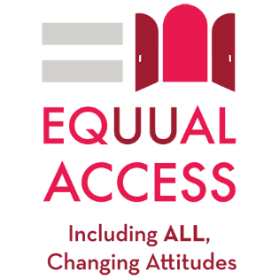

Congregational Accessibility Information to List on Your Website for Disabled UUs

When people first come to your website, they typically land on your ‘home’ page where there is an introduction to your church and congregation. Your church’s welcome message should explicitly include your congregation’s commitment to fully including and embracing disabled people in the life of the congregation.
With the overall look and function of your website, we recommend starting with a ‘what to expect’ type of page. List ways that your building, grounds, and programs are accessible. Such as:
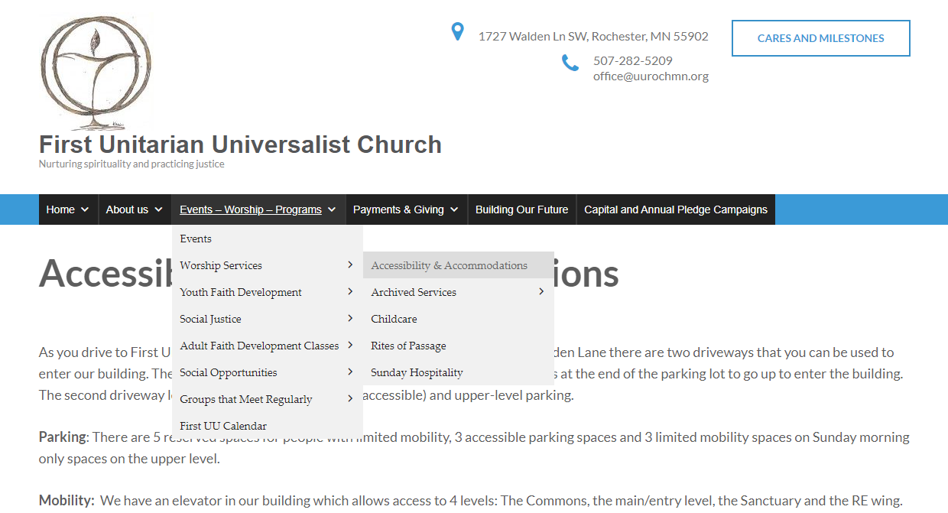

Please list what types of services you offer and where someone could go to get them or information on them. Please provide contact information and links for more information whenever it is possible.

Building and Grounds:
- Map and written description of location of the accessible parking spaces with the location of entrances into the building.
- A way-finder map of the building with written descriptions of location that shows how to navigate the interior building, including where there may be automatic doors and elevators, accessible bathrooms, bathrooms that would accommodate an attendant, transgender bathrooms, and accessible seating in the sanctuary.
- Map with written description of the grounds with accessible paths and doors.
- Information about public transportation to the building; including information on carpools.
- Posting maps may not be possible; describe how someone can locate the above information once they arrive onsite.

Accommodations:
- Loop system or hearing devices, captioning, or sign language interpretation.
- Large print or electronic Orders of Service.
- Braille signage and hymnals.
- Chairs with arms in the Sanctuary, classrooms, or other common areas to provide support for rising from a seated position, accessible coat racks, or handrails in various areas of your building.
- Virtual service links, electronic Order of Service, and location of past services.
- Please note if a portable microphone is available for events.
- Include any other accommodations provided to include people with disabilities in congregational life.

Programs & Services
- Include information about RE and what children with disabilities and their parents or caregivers can expect. Include links to other pages for further information.
- Include information on Pastoral Care and other services available.
- List any support groups and link (if applicable) to their pages such as: AA, Al-Anon, NAMI, grief groups, or groups for people with mental health concerns.
- Include information on your church’s policies regarding:
- Service animals
- Chemical Sensitivity
- Food allergies
- Emergency Procedure
While this list may not be complete, it is rather extensive. It is not important your congregation offer complete accessibility in all these areas. Rather, be upfront about what you can offer so disabled people know what to expect when they visit.

